Task 1: Responsive Portfolio Website
Name: Nethala Roshitha
Role: Frontend Developer Intern

1. Objective
The objective of this project is to design and develop a responsive personal portfolio website using HTML, CSS, and Bootstrap. The website showcases personal skills, projects, and contact details with a modern user interface and mobile-friendly design.

2. Technologies Used
• HTML5
• CSS3
• Bootstrap 5
• JavaScript (basic)
• Git & GitHub

3. Tools Used
• VS Code (Code Editor)
• Chrome Browser
• GitHub (Version Control & Hosting)

4. Features Implemented
• Fully responsive design (mobile, tablet, desktop)
• Navigation bar with smooth scrolling
• Hero section with modern UI
• About section describing profile
• Skills section with technologies
• Projects section with GitHub links
• Contact section with email and social links
• Resume download button

5. Project Structure
portfolio/
│── index.html
│── style.css
│── resume.pdf
└── images/
├── project1.png
├── project2.png
└── project3.png

6. Steps / Commands Used
1. Created project folder:
mkdir portfolio
2. Opened folder in VS Code
3. Created files:
index.html
style.css
4. Initialized Git:
git init
5. Added files:
git add .
6. Commit changes:
git commit -m "Initial portfolio project"
7. Connected GitHub repository:
git remote add origin https://github.com/yourusername/portfolio.git
8. Pushed code:
git push -u origin main
9. Enabled GitHub Pages for live hosting

7. Code Snippets
HTML Example
<section id="projects">
<h2>Projects</h2>
</section>
CSS Example
.card-box {
background: #1f2937;
padding: 20px;
}

8. Screenshots

Home Page:

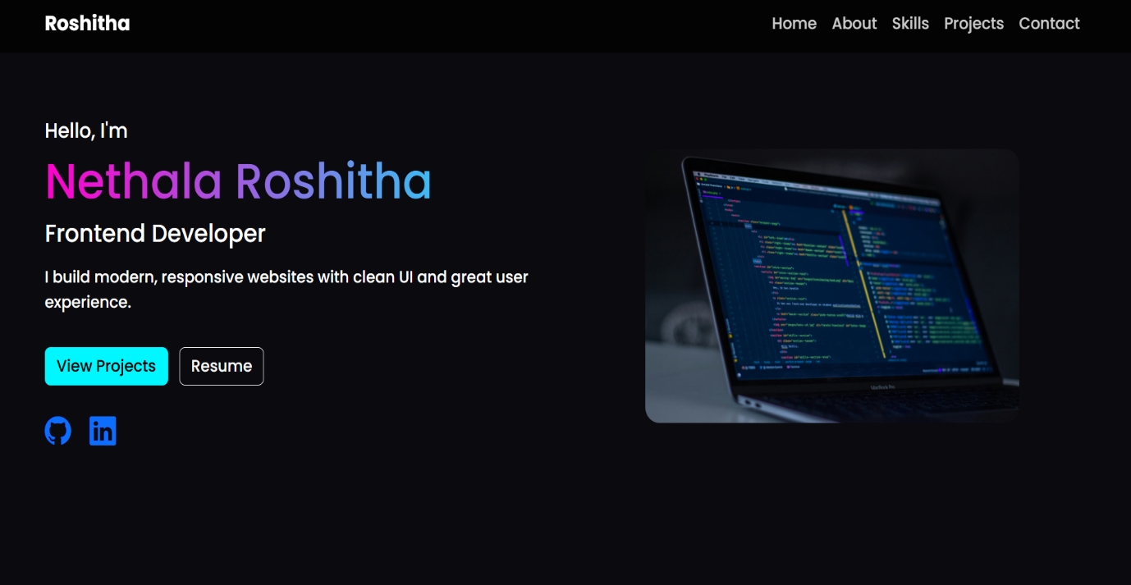

About and skills page:

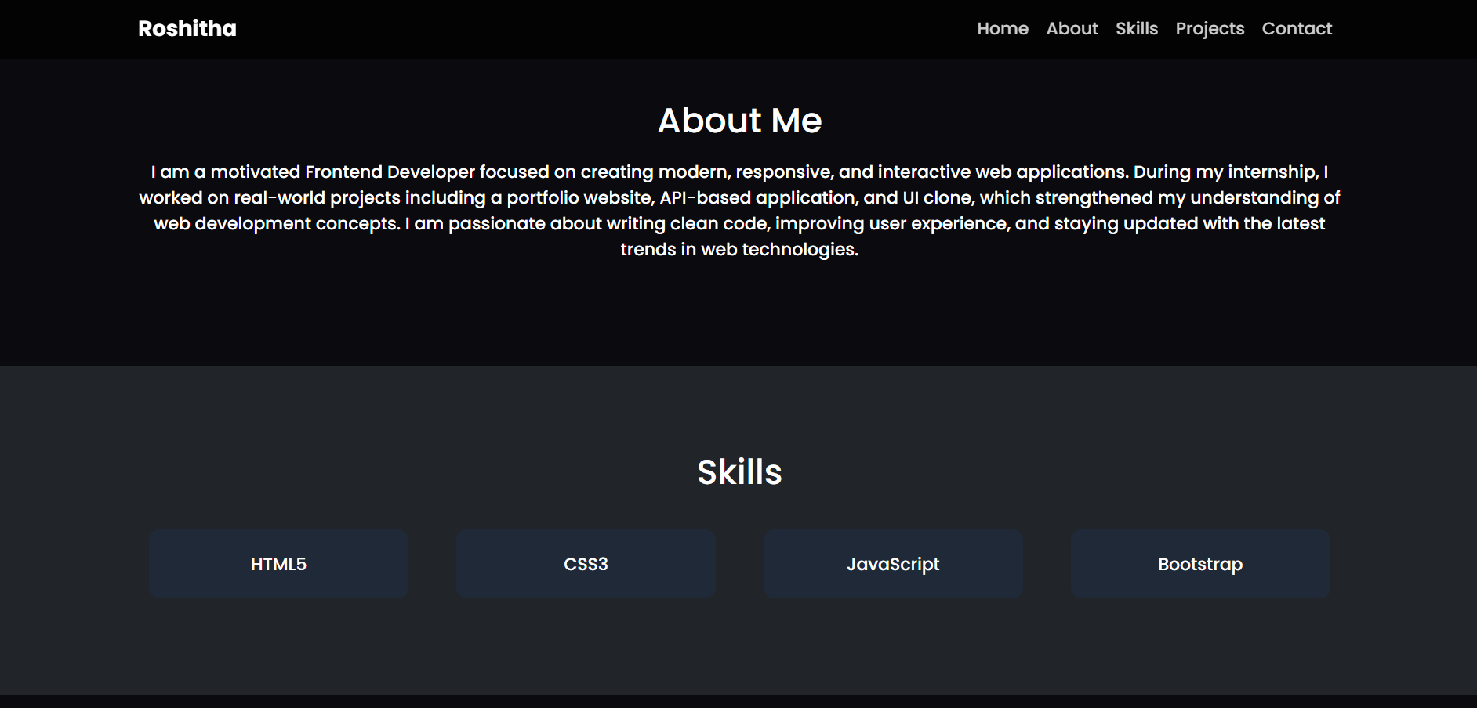

Project page:

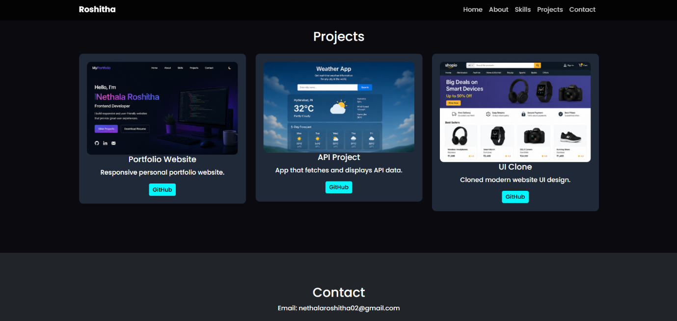

9. GitHub Repository Link
https://github.com/NethalaRoshitha/Portfolio

10. Live Website Link

https://nethalaroshitha.github.io/Portfolio/

11. Challenges Faced
• Making the layout responsive across devices
• Designing clean UI
• Managing spacing and alignment

12. Learning Outcomes
• Learned responsive web design
• Improved HTML & CSS skills
• Understood GitHub workflow
• Built real-world project experience

13. Conclusion
This project helped me gain practical knowledge in frontend development. I successfully built a responsive portfolio website and learned how to deploy it using GitHub Pages.

